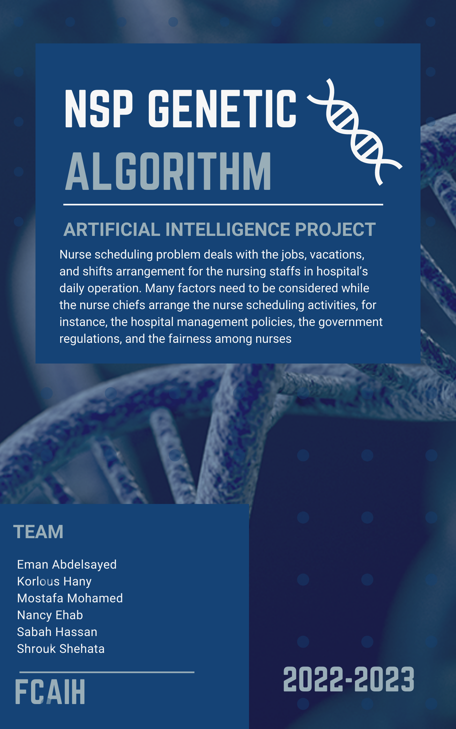

Contents

**Abstract** 3

**Introduction** 4

**Section snippets** 8

Model development 8

Model solving algorithms and process 8

Interactive nurse scheduling system 8

Case overview and problem description 8

**The main functions in the NSP using genetic algorithm:** 10

Conclusion 12

References: 13

A heuristic-based computerized nurse scheduling system 13

Nurse scheduling on a microcomputer 13

Nurse rostering problems – A bibliographic survey 13

A 0–1 goal programming model for nurse scheduling 13

Computerized nurse scheduling 13

**Industrial Engineering** 13

Exploiting problem structure in a genetic algorithm approach to a nurse rostering problem 13

**Journal of Scheduling** 13

Bayesian optimization algorithm for nurse scheduling 13

A multiple objective nurse scheduling model 13

**AIIE Transaction** 13

Integrated days off and shift personnel scheduling 13

**Computer and Operations Research** 13

**Similar applications in the market** 15

Connecteam 15

mHelpDesk 16

TrackSmart 17

Siling 18

Deputy 19

**Details of the algorithm(s)/approach(es) that will be used.** 20

**Development platform.** 22

# **Abstract**

This study develops a two-stage mathematical modeling for a nurse scheduling system wherein hospital management requirements, government regulations, and nursing staffs’ shift preferences are incorporated. In the first stage, the nurse work and vacation schedules are arranged, and genetic algorithm (GA) is used to solve for the optimal schedules and to check for any violation of government regulations, hospital management requirements, and the scheduling fairness. In the second stage, the nurse roster schedule is arranged, and GA is further adopted to solve the optimal schedule. An empirical case study is performed, and the results show that GA can be an efficient tool for solving the nurse scheduling problem. In addition, it can also be easily modified to suit different cases encountered in hospitals.

# **Introduction**

Nurse scheduling problem deals with the jobs, vacations, and shifts arrangement for the nursing staffs in hospital’s daily operation. Many factors need to be considered while the nurse chiefs arrange the nurse scheduling activities, for instance, the hospital management policies, the government regulations, and the fairness among nurses. Cheang, Li, Lim, and Rodrigues (2003) added nursing staffs’ preference into the scheduling factors. Bard and Purnomo (2007) considered factors such as nurse workforce, hospital work and hospital scheduling regulation to establish a schedule-making decision tree. The constraint conditions to nurse scheduling are broad and they may differ from case to case. Some of the constraint conditions even conflict with each other. For instance, the shift preference of nursing staffs may violate the requirement for shift fairness. In practice, the nurse chiefs arrange the nurse scheduling based on their subjective experience. To meet the complicated situations with ever-increasing patient demands and limited nurse workforce, the chiefs may require spending more effort than ever to deal with the nurse scheduling but may still fail to be fair to all nurses. Consequently, the nurse scheduling issue remains challenging and development of more sophisticated approach to solve the nurse scheduling problem deserves further exploration.

In the past, a considerable number of relevant studies on nurse scheduling problem have been found. Smith and Wiggins (1977) divided nurse scheduling modeling into three categories: cyclical scheduling approach, heuristic scheduling approach, and mathematical programming approach. Cyclical scheduling approach sets up shift and vacation arrangement by the nurse chiefs based on the needs of nurse unit, the regulations of hospital, and the number of nursing staffs. Cyclical scheduling approach normally utilizes cyclical scheduling pattern on a fixed time range. For heuristic scheduling approach, the nurse chiefs often construct a decision tree with consideration of nursing staff workforce, nurse service pattern, hospital scheduling policy, and other factors and then utilize the scheduling result on a cyclic basis. Mathematical programming approach is a special mathematical model developed to respond to the scheduling problems for different cases. Normally, it is constructed with objective functions and constraint equations and then utilizes appropriate algorithms to solving for the optimal solutions.

The three categories of nurse scheduling approaches have their advantages and disadvantages. Cyclical scheduling approach can be conveniently executed; however, a new scheduling must be rearranged in case that some nurses need to change their jobs or shifts. In practice, it is quite common for the nurses changing their jobs or shifts. Thus, cyclical scheduling approach does not provide effective ways to deal with the practical problem. Because the interaction relationship among nursing staffs is very complicated, the decision-making tree, constructed by the heuristic scheduling approach, for the scheduling rule is usually huge. When the constraint conditions are numerous, it will generally be difficult for the heuristic scheduling approach to attain a reasonable solution. As a result, the nurse scheduling activities cannot be easily processed (Harvey & Mona, 1998). Mathematical programming approach shows a substantial level of dependency on the cases addressed. When dealing with different cases, the mathematical scheduling model requires further re-formulated.

Nurse scheduling system can be developed and treated in various ways. Ahuja and Sheppard (1975) developed a four-module four-stage interactive cyclical scheduling system, which used the computer to arrange schedules for different nursing staffs. Their system consists of four modules: (1) work pattern selector – it identifies cyclical schedule patterns from the inputted information, different case hospitals may have different work patterns; (2) work schedule assembler–it combines nursing staffs with the work patterns generated by the first module; (3) work schedule projector–it displays the work schedules for both the individuals and the organization; (4) work prediction and allocation of staffs – it designs a work load index according to the requirements of the nursing staffs and then assigns work to staffs based on this work load index. Smith and Wiggins (1977) developed a batched three-stage cyclical scheduling system to arrange the nurse scheduling, which includes (1) summarizing the requirements of staffs for specified units on weekly bases; (2) generating preliminary schedules and evaluating the schedules with the constraint conditions to check if there is any conflict; and (3) manually adjusting the preliminary schedule and creating the finalized schedule. Kostreva and Jenning (1991) indicated that a nurse scheduling system should include survey module and scheduler module.

Integer programming, mixed integer programming, goal programming, linear programming, network programming, and constraint programming have been used for solving the nurse scheduling problem. For instance, Miller, Pierskalla, and Rsth (1976) and Ozkarahan and Bailey (1988) utilized the integer programming to search for a schedule with the lowest aversion deviations; whereas Warner (1976) employed goal programming with multiple choices to solve nurse scheduling problems. Kostreva, Lescyski, and Passini (1978) and Bell, Hay, and Liang (1986) developed mixed integer programming models to solve nurse scheduling problems; while Arthur and Ravindran (1981) used 0–1 goal programming to solve two-stage cyclical scheduling problems. Musa and Saxena (1984) adopted 0–1 goal programming and heuristic search to solve nurse scheduling problems. Azaiez and Al Sharif (2005) also used 0–1 goal programming to solve nurse scheduling problem. Bailey (1985) developed a cyclical scheduling model with integer programming. Brigitte, Semet, and Vovor (1998) utilized linear programming to obtain the solution that can simultaneously minimize the total payment, satisfy the staff preference, and level the nurse workforce. Harvey and Mona (1998) employed network programming to study the cyclical and non-cyclical nurse scheduling problems for the base of 12-h shifts. Meyer auf’m Hofe (2001) used constraint programming to solve nurse scheduling problems.

Other techniques have also been found to tackle the nurse scheduling problems. Randhawa and Stiompul (1993) developed a heuristic scheduling decision-making support system to handle the multiple-goal programming problems with binary variables; whereas Aickelin and Dowsland (2000) used genetic algorithms to solve nurse scheduling problems. Dowsland and Thompson (2000) combined Tabu search and network programming to establish a non-cyclical scheduling system; while Knjazew (2002) used genetic algorithms to solve cyclical scheduling problems. Aickelin and Li (2006) used Bayesian optimization algorithm to solve nurse scheduling problems.

Goldberg (1989) and Sharif (2000) pointed out that the advantages of GA are numerous. GA can solve the optimization problem with multiple variables; it can perform parallel processing, which can effectively save processing time. GA does not need to calculate the differential value of the fitness function because natural selection process is determined by the fitness of chromosome; it is a multiple points search instead of a single point search approach, which owns a relatively high probability to find the value that is quite close to the global optimum rather than being trapped in a local search. In addition, GA is suitable to work in computer environment. In light of these advantages, this study attempts to develop a different approach by integrating mathematical programming approach with the GA to solve the nurse scheduling problem. When dealing with different cases, the solving algorithm is not necessarily re-adjusted. Instead, we only need to set new objective functions and constraint conditions.

This study will incorporate the hospital management requirements, government regulations, and nursing staffs’ shift preferences into a two-stage mathematical model. In the first stage, the nurse work and vacation schedules are to be arranged in the model and GA is used to solve for the optimal schedule and to check for any violation for government regulations, hospital management requirements, or the scheduling fairness. In the second stage, the nurse roster schedule is arranged and GA is further adopted to solve the optimal schedule. The remaining parts of this paper are organized as follows. Section 2 develops the nurse work and vacation model and the nurse roster schedule model. Section 3 introduces the GAs for solving both models. In Section 4, an otolaryngology hospital in Tainan, Taiwan is studied as our empirical case. Lastly, the concluding remarks are addressed.

# **Section snippets**

## Model development

This study builds up a two-stage mathematical model for a nurse scheduling system. In the first stage, the nurse work and vacation schedule are arranged based on the vacation schedule arranged by every nurse staff. GA is used to build the optimal schedules and to check for any violation of government regulations, hospital management requirement, and the scheduling fairness. In the second stage, the nurse roster schedule is arranged, and GA is further adopted to solve the optimal schedule.

## Model solving algorithms and process

This study divides nurse scheduling operation into two models: work and vacation schedule and roster schedule. The followings are solving algorithms and process of these two models.

## Interactive nurse scheduling system

This study performs the optimization process of these schedules with GA based on nursing staffs’ self-arranged schedules. The procedures for the scheduling system are listed as follows: (1) input the personal account number and password to enter the individual front page. The functions of this page include personal schedule input and modification, personal schedule inquiry, comprehensive schedule inquiry, etc., (2) list the number of days available for vacation of the nurse staff in the next

## Case overview and problem description

This study takes the scheduling activities of the nurse staff in an otolaryngology hospital in Tainan, Taiwan, as the research case. The hospital in concern has 15 nurse staffs. Through interview we sum up the scheduling consideration factors of that hospital as follows: (1) there are two shifts in normal work days (Monday – Saturday, national holidays excluded): day shift (from AM 8:00 to PM 4:00), night shift (from PM 4:00 to AM 0:00), and for Sundays and national holidays there is only one.

# **The main functions in the NSP using genetic algorithm:**

1. **Enter data**

* Each nurse must enter the required data to make the nurse scheduling, including the appropriate shift, specialization, and ….

1. **Assign nurses to shifts**

* The nurse scheduling problem involves the assignment of shifts and holidays to nurses. Each nurse has their own wishes and restrictions, as does the hospital. The problem is described as finding a schedule that both respects the constraints of the nurses and fulfils the objectives of the hospital.

1. **Ensure each nurse have only one shift per day**

* A nurse does not work the day shift, night shift and late-night shift on the

same day (for obvious reasons)

1. **Ensure all patients have nursing coverage**

* I must make sure that all patients receive full care on all shifts, whether the day shift, night shift and late-night shift, and I make sure that there is no negligence or negligence towards the patient

1. **Ensure each nurse don't have two following shifts**

* Avoid working for nurses in late night shifts followed by a work shift the next day. because this will affect the nurses’ concentration and health, which will lead to patients’ neglect and deterioration of their health.

1. **View a nurse scheduling**

* View the best schedule I can come up with those respects nurse constraints and achieves hospital goals by helping genetic algorithm.

## Conclusion

This study combines GA and interactive web technology to construct a nurse scheduling information system. The contributions of this study are listed as follows:

(1)

Utilize GA to solve the multi-objectives nurse scheduling problem. This model can cope with different cases without re-writing the core algorithm and is highly adaptive to different cases.

(2)

Propose two important issues highly valued by nursing staffs when developing the scheduling model: one is the staff fairness principle and the other is meet the patient's need ….

## References:

* S.U. Randhawa*et al.*

### [A heuristic-based computerized nurse scheduling system](https://www.sciencedirect.com/science/article/pii/030505489390105R)

**Computers and Operations Research**

(1993)

* M.M. Kostreva*et al.*

### [Nurse scheduling on a microcomputer](https://www.sciencedirect.com/science/article/pii/030505489190011F)

**Computers and Operations Research**

(1991)

* B. Cheang*et al.*

### [Nurse rostering problems – A bibliographic survey](https://www.sciencedirect.com/science/article/pii/S0377221703000213)

**European Journal of Operational Research**

(2003)

* M.N. Azaiez*et al.*

### [A 0–1 goal programming model for nurse scheduling](https://www.sciencedirect.com/science/article/pii/S0305054803002491)

**Computer and Operations Research**

(2005)

* H. Ahuja*et al.*

### Computerized nurse scheduling

### **Industrial Engineering**

(1975)

* U. Aickelin*et al.*

### Exploiting problem structure in a genetic algorithm approach to a nurse rostering problem

### **Journal of Scheduling**

(2000)

* U. Aickelin*et al.*

### Bayesian optimization algorithm for nurse scheduling

* J.L. Arthur*et al.*

### A multiple objective nurse scheduling model

### **AIIE Transaction**

(1981)

* Meyer Auf’m Hofe, H. (2001). Solving rostering tasks as constraint optimization. In E. K. Burke & W. Erben (Eds.),...
* J. Bailey

### Integrated days off and shift personnel scheduling

### **Computer and Operations Research**

(1985)

**Other reviews:**

1- A Hybrid Genetic Algorithm for Nurse Scheduling Problem considering the Fatigue Factor .

<https://www.hindawi.com/journals/jhe/2021/5563651/>

2- optimization of nurse scheduling problem using genetic algorithm .

<https://iopscience.iop.org/article/10.1088/1757-899X/536/1/012131/meta>

3- Comparative Performance of Simulated Annealing and Genetic Algorithm in Solving Nurse Scheduling Problem .

[icaia_34_camera (iaeng.org)](http://www.iaeng.org/publication/IMECS2008/IMECS2008_pp96-100.pdf)

4- An Indirect Genetic Algorithm for a Nurse Scheduling Problem .

<https://arxiv.org/pdf/0803.2969>

5- A Genetic Algorithm Approach for Nurse Assignment Problem .

<https://www.pomsmeetings.org/confpapers/025/025-0701.pdf>

6- A Strategy to Improve Performance of Genetic Algorithm for Nurse Scheduling Problem .

[Journal Paper Format (hallym.ac.kr)](https://interaction.hallym.ac.kr/pdf/2014/2014_01.pdf)

7- Solving the Nurse Scheduling Problem of Private Hospitals in the Philippines using Various Operators for Genetic Algorithm.

[Solving-the-Nurse-Scheduling-Problem-of-Private-Hospitals-in-the-Philippines-using-Various-Operators-for-Genetic-Algorithm.pdf (researchgate.net)](https://www.researchgate.net/profile/Rhoda-Namoco-2/publication/312516116_Solving_the_Nurse_Scheduling_Problem_of_Private_Hospitals_in_the_Philippines_using_Various_Operators_for_Genetic_Algorithm/links/611fe0ef1e95fe241ae71d9b/Solving-the-Nurse-Scheduling-Problem-of-Private-Hospitals-in-the-Philippines-using-Various-Operators-for-Genetic-Algorithm.pdf)

8- Nurse Scheduling with Joint Normalized Shift and Day-Off Preference Satisfaction Using a Genetic Algorithm with Immigrant Scheme.

[Nurse Scheduling with Joint Normalized Shift and Day-Off Preference Satisfaction Using a Genetic Algorithm with Immigrant Scheme - Chun-Cheng Lin, Jia-Rong Kang, Ding-Jung Chiang, Chien-Liang Chen, 2015 (sagepub.com)](https://journals.sagepub.com/doi/full/10.1155/2015/595419)

# **Similar applications in the market**

## Connecteam

Connecteam is an award-winning nurse scheduling software designed for managers to create, assign, and oversee shifts in just a couple of clicks. Nurses have instant access to their digital schedule from a mobile app that is super easy to use and navigate.

Many medical facilities and agencies already use this all-in-one software solution to provide nurses with accurate schedules in an instant instead of manual spreadsheets and messy paper-based schedules. With Connecteam’s nurse scheduling software, you can Easily plan and allocate shifts for your nurses.

## mHelpDesk

mHelpDesk is very similar to Google Calendar and Outlook but was designed especially for those in the field service business. A few core features of this work schedule app include quickly see everyone’s availability, easily schedule field technicians, automated assignment notifications, view job, and customer details, and eliminate overbooking and underbooking. mHelpDesk can also integrate with Google Calendar, Home Advisor, and QuickBooks.

## TrackSmart

TrackSmart Scheduling allows you to schedule in advance.

TrackSmart can be accessed from any device, anywhere, anytime.

Workers can make changes to their shifts without your input.

## Siling

Sling makes it easy to create employee schedules, manage time off, availability, and shift swapping. Schedule overtime, reduce absenteeism, and late arrivals, and you can also receive notifications of overlapping shifts or double-booking. Save scheduling templates so creating new ones is a breeze.

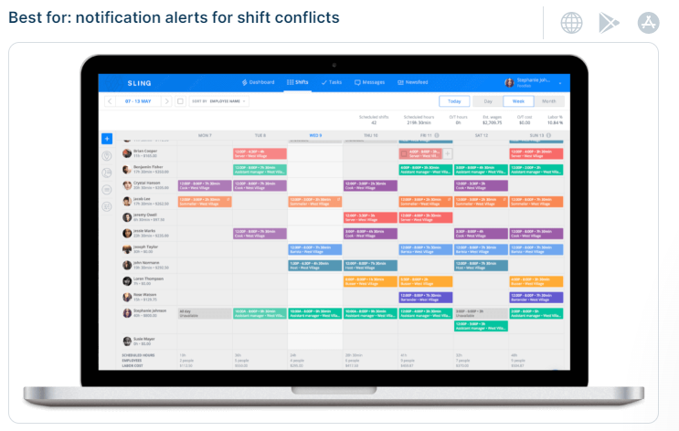

## Deputy

When using Deputy, you really need to be tech-savvy and Deputy knows it – that’s why they request all your pen and paper timesheets and scheduling ahead of time so that they can customize the work schedule app to meet your business needs.

Some of their scheduling features include auto-scheduling with lunch and rest breaks. You can create, copy, or publish schedules, shift swapping, and shift replacements. Also, Deputy integrates the software with POS and HR systems like Gusto, Xero, QuickBooks, Lightspeed, and more.

# **Details of the algorithm(s)/approach(es) that will be used.**

***What are Genetic Algorithms?***

Genetic algorithms (GAs) are based on evolutionary biology in its core concepts. The genetic information for an organism is initially kept in a cell's chromosomes. In biology, a population's two chromosomes are known as crossing (or mate) as parents to create children who could be vulnerable to genetic mutation at random.

The most fit or powerful of these offspring, survive and create new populations.

GAs is identical to these basic ideas. The population of the GA is made up of NSP solutions. The Parents are solutions chosen at random, crossover is a created operator on a solution, mutation is a change in the solution made at random, and to identify which solutions should advance, we use a fitness assessor between the ages.

**Proposed Coding:**

• Each searches proposes the schedule for selected days with selected no. of nurses (input).

• It is a string of n elements, n being the number of nurses.

• Each element is the index of the shift pattern worked by a nurse.

Crossover gives some nurses the shifts worked in one parent

solution and the remainder those worked in the other parent.

Mutation changes the worked shift of one nurse.

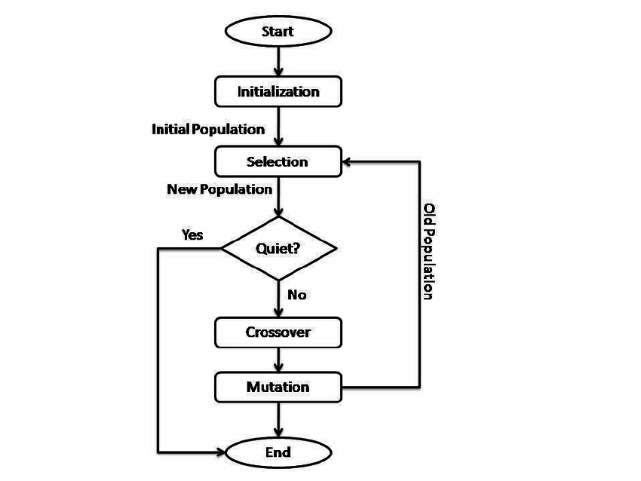**Algorithm approach:**

*Genetic Algorithm (NSP)*

*Initialize a Population of Individuals*

*While Stop Criterion not met*

*Selection of Individuals to Combine*

*Application of Crossover Operator*

*Application of Mutation Operator*

*Application of Local Search Heuristics*

*Evaluation of Fitness of the Newly Created Individuals*

*Update Population*

*End while*

**Block diagram for system Nurse Scheduling Problem in our system:**

# **Experiments & Results**

We experimented our system several times to make sure that all the constraints are satisfied and there are no faults on invalid options that the preferences are violating.

We measured that through that for each constraint we calculated its fitness and objective rate to ensure that we can measure and test the validity of each constraint alone.

Testing with these values:

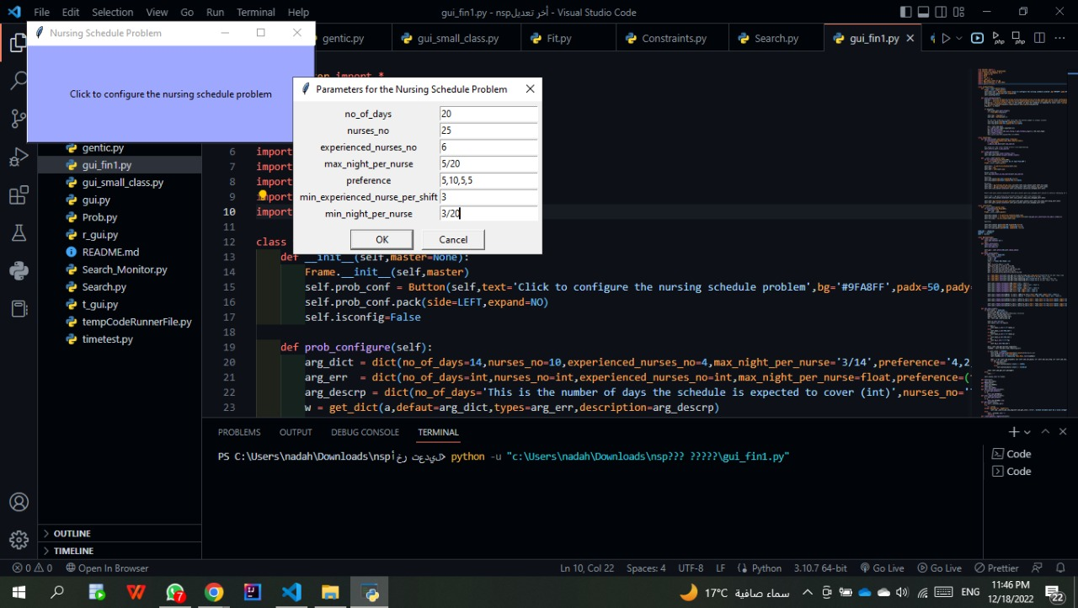

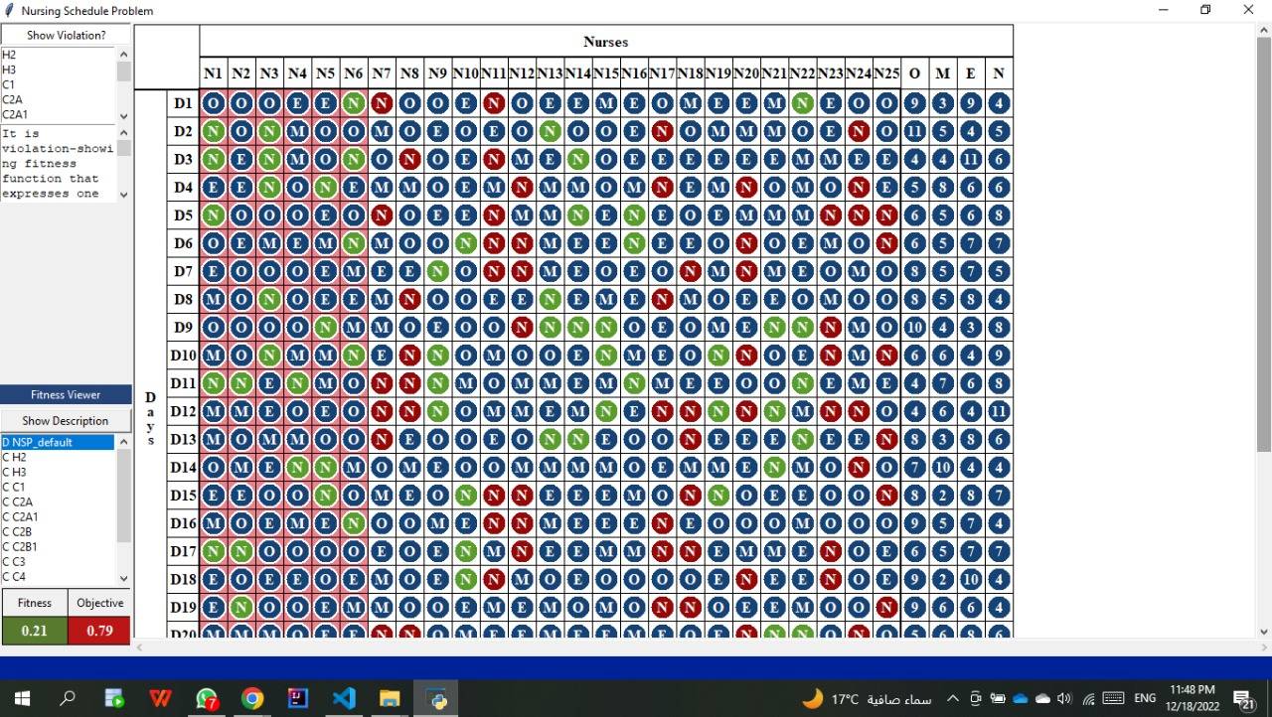Results:

# **Development platform.**

**Tools:** Visual Studio Code

**Programming Languages:** Python

**Python Libraries:**

Numpy,tkinter, functools, tkinter.ttk,